Welcome to Mrs. Lipsey’s Study Skills Class
Syllabus

I. Course Objective
The objective of this course is to give students the opportunity to develop and strengthen good study habits, learning strategies, as well as have some time to work on their classwork and ask me for help (if needed).
We will address the following topics:
- Setting Goals | - Time Management | - Learning Stragegies
- Making a Graduation Plan  - Organization | - Tracking Progress  - Learning Styles | - Test Preparation  - Test Taking Strategies

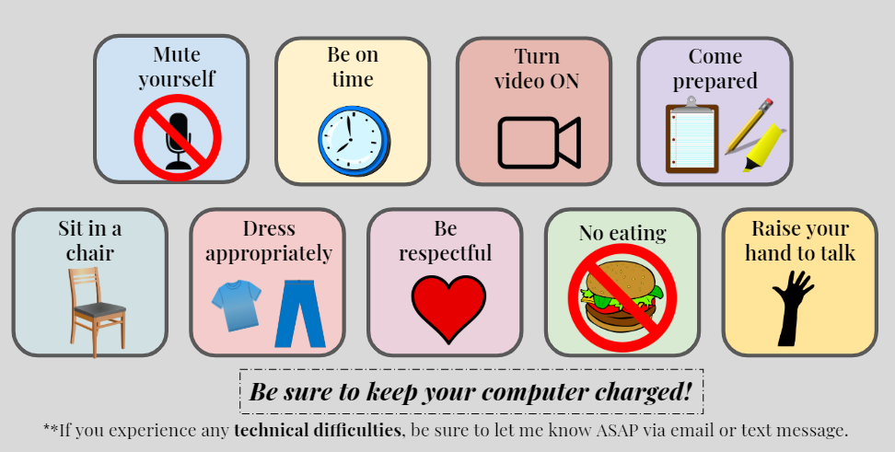
Google Classroom Etiquette:

II. My Grade Breakdown
- Attendance & Participation = 15%
- Camera ON = 15%
- Assignments & Activities = 35%
- Classes Passed = 35%

III. Tutoring/Extra Help: Every Monday thru Thursday 12 - 1pm on Google Meet (class code dsi4xsp) or you can click on the link on my webpage. I am always there.

IV. My Contact Information Email: janice_lipsey@chino.k12.ca.us
Google Voice/(Text is best!): (909) 334-2575‬ ‬‬‬‬‬‬‬

